**Results:**

**Userstory 1**

**A screenshot of a computer

Description generated with very high confidence**

**User story 2**

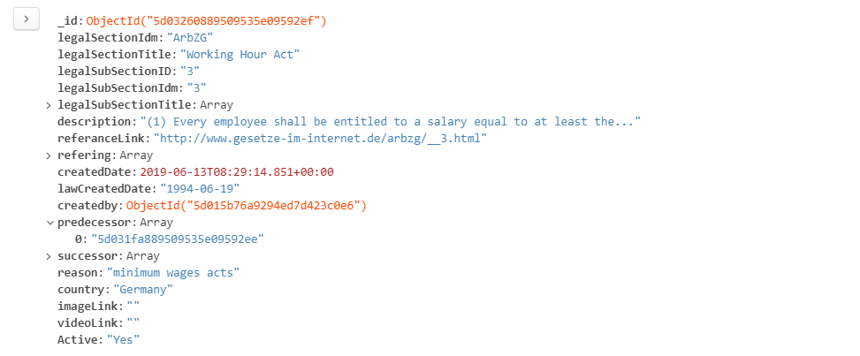

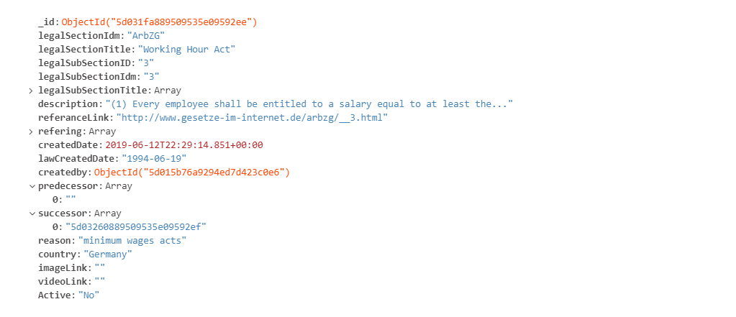

**User story 3**

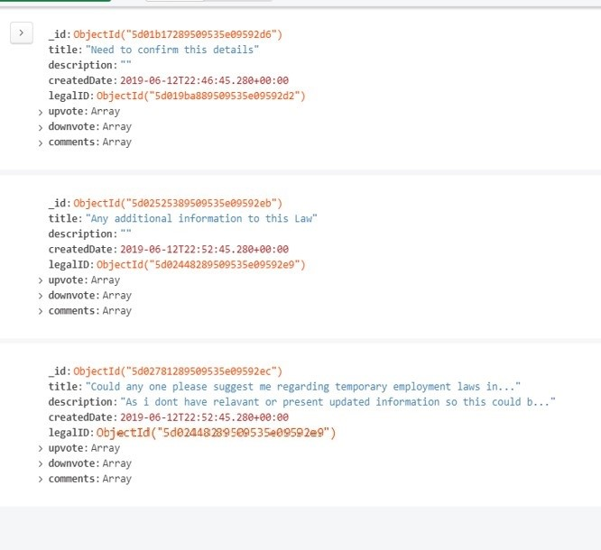

**Comment**

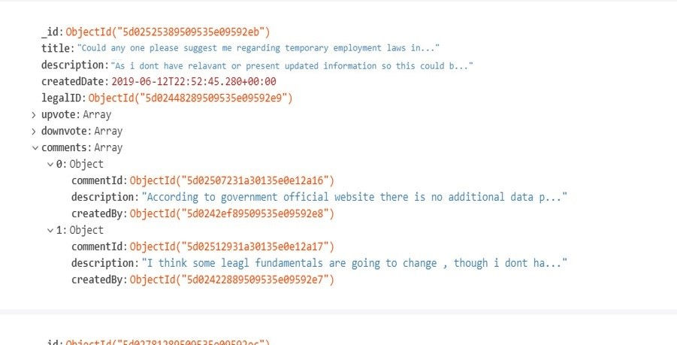

**Neo4j**

CREATE

(`0` :legal {section_id:'44g01b172807j0535e19d9b7d',section:'Sub_Section_18a'}) ,

(`1` :user {user_id:'6g01b17dm056l8jhe964b2f88',user:'user_12'}) ,

(`2` :user {user_id:'9tg01b176m055l83e934229u8',user:'user_13'}) ,

(`3` :user {user_id:'7g01b1764056l8jhe964b29p3',user:'user_10'}) ,

(`4` :user {user_id:'8p01b176j056l8jhe964b29q3',user:'user_11'}) ,

(`5` :user {user_id:'3g01b176m056l8jhe964b291',user:'user_9'}) ,

(`6` :user {user_id:'99g0sb176m356l8jhe964b298',user:'user_8'}) ,

(`7` :user {user_id:'9g01b176k051l8jhe764b294',user:'user_7'}) ,

(`8` :user {user_id:'3g01b176m056l8jhe964b291',user:'user_5'}) ,

(`9` :user {user_id:'6g01b1786805gl8jhe924b798',user:'user_4'}) ,

(`10` :user {user_id:'4g01b1761050h8jhe954b79t9',user:'user_2'}) ,

(`11` :user {user_id:'3g01b1768050l8jhe954b798',user:'user_1'}) ,

(`12` :user {user_id:'2g01b172805008jhe959b799',user:'user_6'}) ,

(`13` :user {user_id:'1g01b176805ul8jhe954b790',user:'user_3'}) ,

(`14` :legal {section_id:'74g01b172805j0535e19d9b7g',section:'Sub_Section_18b'}) ,

(`15` :legal_main {section_id:'27k0eb172807j0535e1fd9b7f',section:'Legal_Section_Main'}) ,

(`16` :legal {section_id:'954g01bp72807j0535e19d9b7k',section:'Sub_Section_18c', flag: ‘suspended’}) ,

(`17` :thread {thread_id:'84g0py1723lo84638a857p228'}) ,

(`18` :thread {thread_id:'8m4j0pb1k2505jk935719dkb75'}) ,

(`19` :thread {thread_id:'74g0pb1l2505jk935e19dkb754'}) ,

(`20` :thread {thread_id:'7g01b1t28u7r05p5e1959b74'}) ,

(`21` :thread {thread_id:'24g0pb172505jk535e19d9b7v'}) ,

(`22` :comment {comment_id:'34g0pb189h48p5h757k452j'}) ,

(`23` :`comment ` {comment_id:'84f0pb189348p5h757u452b2'}) ,

(`24` :legal {legal_id:'7g01b17610saa0h8jhd954b7g',section:'Sub_Section_modified', flag: ‘active’}) ,

(`25` :comment {comment_id:'7g01b172805608jhy959b7u9'}) ,

(`2`)-[:`created` {comment_by:'9tg01b176m055l83e934229u8'}]->(`23`),

(`23`)-[:`under` ]->(`17`),

(`11`)-[:`dicussion` ]->(`17`),

(`10`)-[:`upvote` {upvote_by:'4g01b1761050h8jhe954b79t9'}]->(`17`),

(`13`)-[:`dicussion` ]->(`19`),

(`19`)-[:`under` ]->(`16`),

(`17`)-[:`under` ]->(`16`),

(`13`)-[:`upvote` {upvote_by:'1g01b176805ul8jhe954b790'}]->(`23`),

(`18`)-[:`under` ]->(`16`),

(`16`)-[:`modified` ]->(`24`),

(`16`)-[:`under` ]->(`15`),

(`24`)-[:`under` ]->(`15`),

(`0`)-[:`under` ]->(`15`),

(`14`)-[:`under` ]->(`15`),

(`21`)-[:`under` ]->(`14`),

(`20`)-[:`under` ]->(`0`),

(`6`)-[:`dicussion` ]->(`18`),

(`12`)-[:`follow` {follow_id:'3g01b176m056l8jhe964b291'}]->(`5`),

(`12`)-[:`follow` {follow_id:'3g01b176m056l8jhe964b291'}]->(`8`),

(`8`)-[:`follow` {follow_id:'2g01b172805008jhe959b799'}]->(`12`),

(`12`)-[:`follow` {follow_id:'2g01b172805008jhe959b799'}]->(`4`),

(`12`)-[:`follow` {follow_id:'2g01b172805008jhe959b799'}]->(`3`),

(`3`)-[:`dicussion` ]->(`21`),

(`8`)-[:`dicussion` ]->(`20`),

(`3`)-[:`follow` {follow_id:'5d401b17p805008jhe959b70p5'}]->(`9`),

(`9`)-[:`read` ]->(`21`),

(`7`)-[:`follow` {follow_id:'9g01b1y2805008jhe959b7k0'}]->(`6`),

(`1`)-[:`created` {created_by:'6g01b17dm056l8jhe964b2f88'}]->(`25`),

(`25`)-[:`under` ]->(`20`)

A close up of a mans face

Description generated with high confidence

A screenshot of a cell phone

Description generated with very high confidence

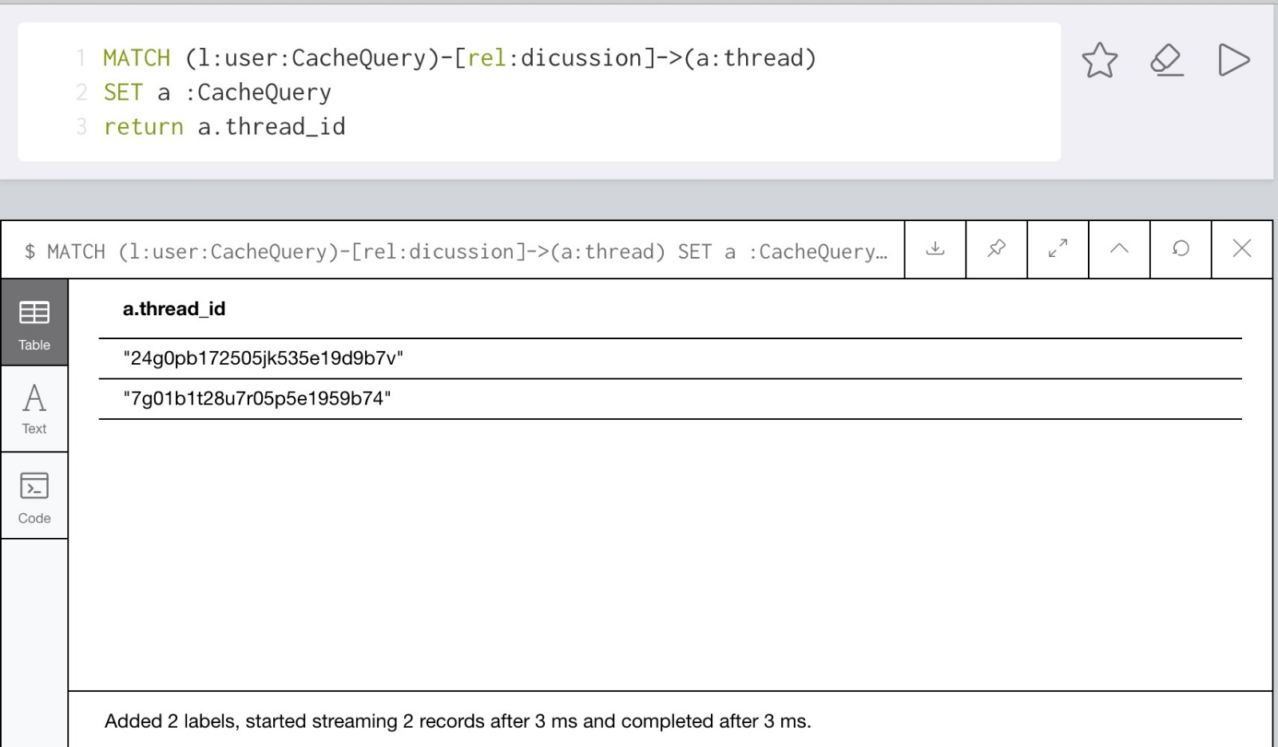

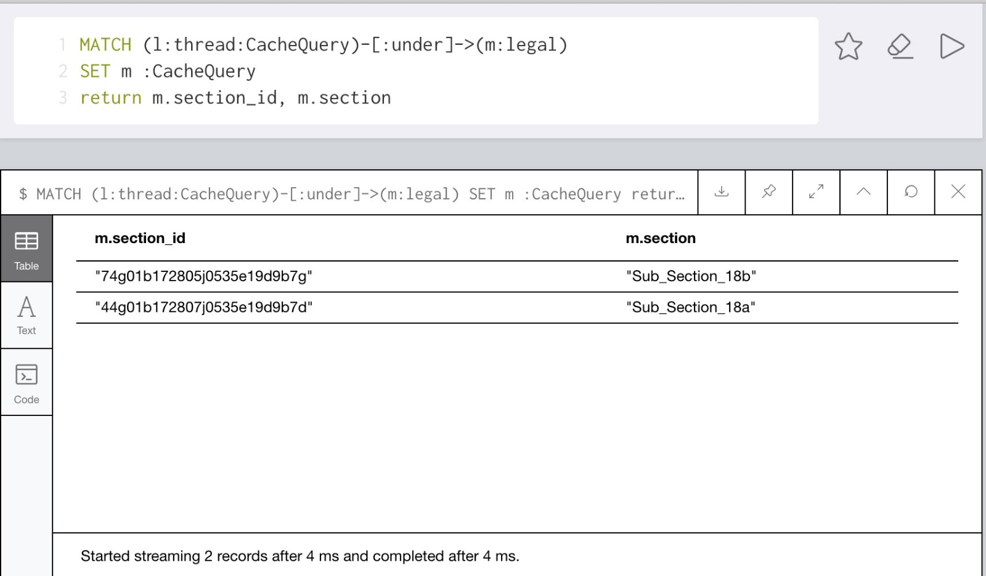

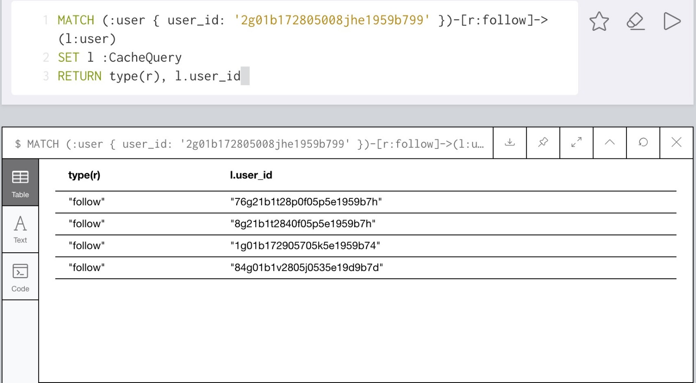

User stories 5:

User story 6

Data synchronization



